**Assignment Overview**

**Architecture:**

* Implemented SOA (Service Oriented Architecture)

**I have created THREE projects for this assignment:**

* WCF REST API (I can also create svc service and add reference in web but this architecture is very popular and more flexible)
* WEB Project
* Common project for Model classes and functions

**Design Pattern:**

* Dependency Inject => Unity
* Facade design pattern
* Factory design pattern
* Implement OOP

**Tools and Technologies**

* Visual Studio 2010
* SQLite Database
* MVC
* Telerik Kendo Controls
* I’ve Implement ADO.NET but If you want I can change it into Entity Framework
* Bootstrap Theme
* Exceptional Handling

**Architecture Diagram**

|  |  |
| --- | --- |
| **WEB Project** | **WCF REST API Project** |

**WCF Service browser View:**

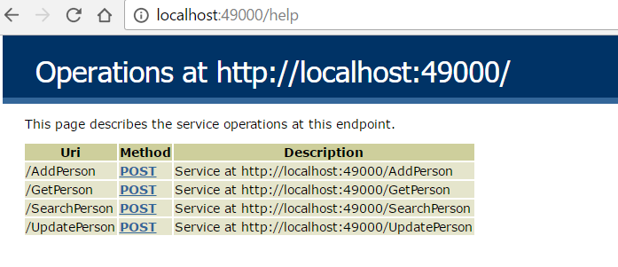

**Application Screenshot:**

* 1. **Retrieving Data from Database**

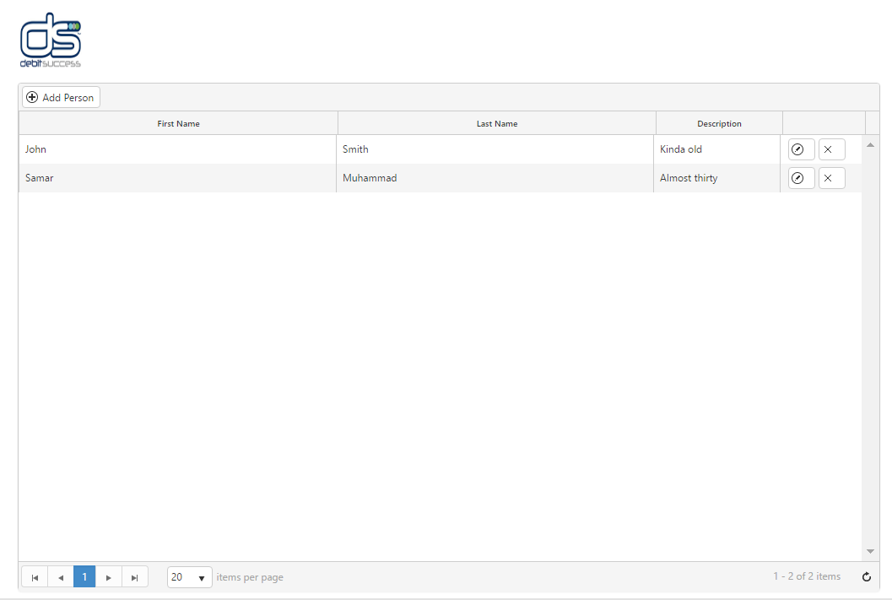

* 1. **User click on “Add Person” button. Click on “Edit button” to update the existing person.**

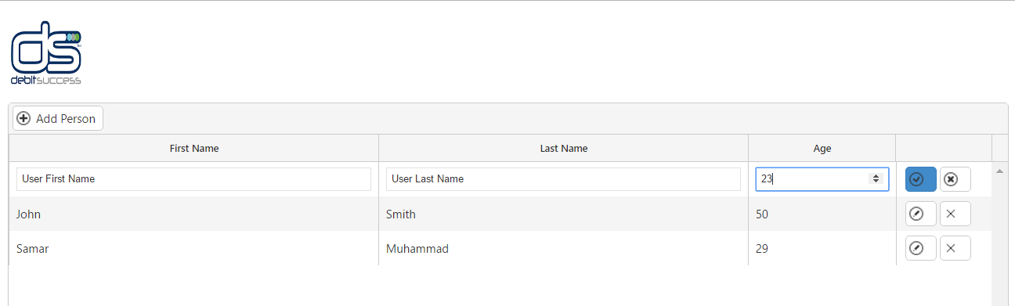

**NOTE:**

1. **WCF service is hosted on local visual studio port 49000 but you can also configure it on IIS**
2. **Please configure the database configuration:**

“AgeRangeApp => Service.Implement” in Web.config

